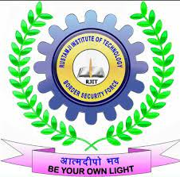

**Industrial Internship Report on**

**”Password Manager”**

**Prepared by**

**Bibha Chand**

|  |
| --- |
| *Executive Summary* |
| This report provides details of the Industrial Internship provided by upskill Campus and The IoT Academy in collaboration with Industrial Partner UniConverge Technologies Pvt Ltd (UCT).  This internship was focused on a project/problem statement provided by UCT. We had to finish the project including the report in 6 weeks’ time.  My project was Python's Password Manager is an intriguing and straightforward project. A password manager is a tool that lets users generate, save, and manage all of their passwords safely within a single local or online application. Create a password manager using the Python programming language.  This internship gave me a very good opportunity to get exposure to Industrial problems and design/implement solution for that. It was an overall great experience to have this internship. |



**Description**: The password manager is a Python project that securely stores and manages user passwords. It allows users to store their passwords for various accounts, generate strong passwords, and retrieve passwords when needed.

In this century there are many social networking accounts, websites, and other online accounts all require a safe password in the twenty-first century. The main disadvantage of using the same password across numerous accounts is that if someone learns it, they can access all of your accounts. Keeping track of so many different passwords is challenging. By developing a basic system for managing passwords, we can accomplish that.

Are you someone who struggles to remember all of your passwords? Have you ever thought about using a password manager? Then you should definitely try password manager system.

A password manager is a python program which allows users to securely store, generate, and manage all their passwords.

This application will generate a password based on the desired length given as input by the user. It will also save the password along with user Name to a database.



**TABLE OF CONTENTS**

1 Preface 4

2 Introduction 5

2.1 About UniConverge Technologies Pvt Ltd 5

2.2 About upskill Campus 9

2.3 Objective 11

2.4 Reference 12

2.5 Glossary 12

3 Problem Statement 13

4 Existing and Proposed solution 14

5 Proposed Design/ Model 15

6 Performance Test 16

6.1 Test Plan/ Test Cases 17

* 1. Performance Outcome 18

7 My learnings 19

8 Future work scope 20

# 

# Preface

In my 6 week’s Internship on python programming language from upskill I have learn all the basics about Python. I learned about the fundamentals of Python, a computer programming language, as well as its history, including who and when it was founded and when Python first gained popularity and its data types along with functions used in python and also about some libraries like Numpy and Pandas.

Python is a widely used general-purpose, high level programming language. It was initially designed by Guido van Rossum in 1991 and developed by Python Software Foundation. It was mainly developed for emphasis on code readability, and its syntax allows programmers to express concepts in fewer lines of code. Python is a programming language that lets you work quickly and integrate systems more efficiently. Python is a high-level, interpreted, interactive and object-oriented scripting language. Python is designed to be highly readable. It uses English keywords frequently where as other languages use punctuation, and it has fewer syntactical constructions than other languages.

Thank you to upskill for this opportunity.

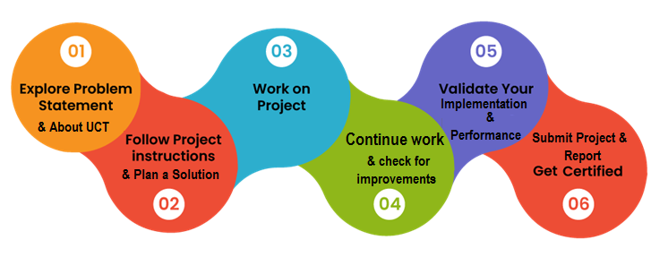

# Introduction

## About UniConverge Technologies Pvt Ltd

A company established in 2013 and working in Digital Transformation domain and providing Industrial solutions with prime focus on sustainability and RoI.

For developing its products and solutions it is leveraging various**Cutting Edge Technologies e.g. Internet of Things (IoT), Cyber Security, Cloud computing (AWS, Azure), Machine Learning, Communication Technologies (4G/5G/LoRaWAN), Java Full Stack, Python, Front end**etc.

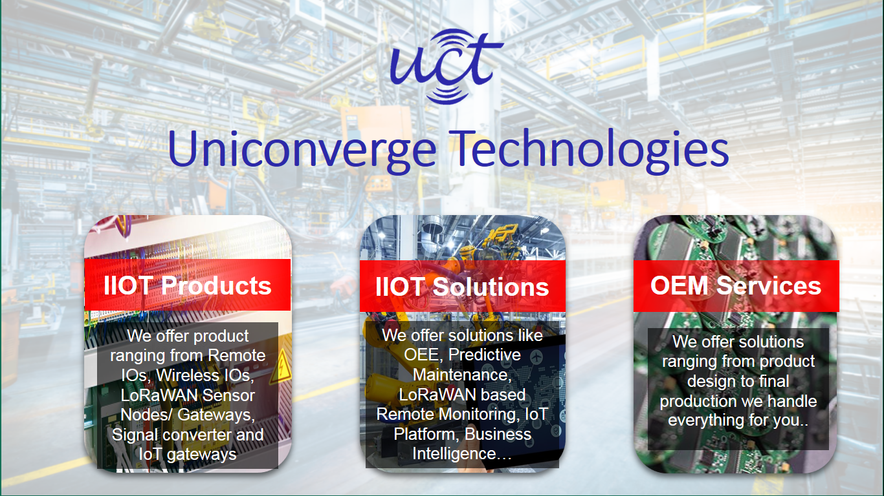

1. UCT IoT Platform **(****)**

**UCT Insight** is an IOT platform designed for quick deployment of IOT applications on the same time providing valuable “insight” for your process/business. It has been built in Java for backend and ReactJS for Front end. It has support for MySQL and various NoSql Databases.



* It enables device connectivity via industry standard IoT protocols - MQTT, CoAP, HTTP, Modbus TCP, OPC UA
* It supports both cloud and on-premises deployments.

It has features to  
• Build Your own dashboard  
• Analytics and Reporting  
• Alert and Notification  
• Integration with third party application(Power BI, SAP, ERP)  
• Rule Engine

 



1. **Smart Factory Platform (****)**

Factory watch is a platform for smart factory needs.

It provides Users/ Factory

* with a scalable solution for their Production and asset monitoring
* OEE and predictive maintenance solution scaling up to digital twin for your assets.
* to unleased the true potential of the data that their machines are generating and helps to identify the KPIs and also improve them.
* A modular architecture that allows users to choose the service that they what to start and then can scale to more complex solutions as per their demands.

Its unique SaaS model helps users to save time, cost and money.

 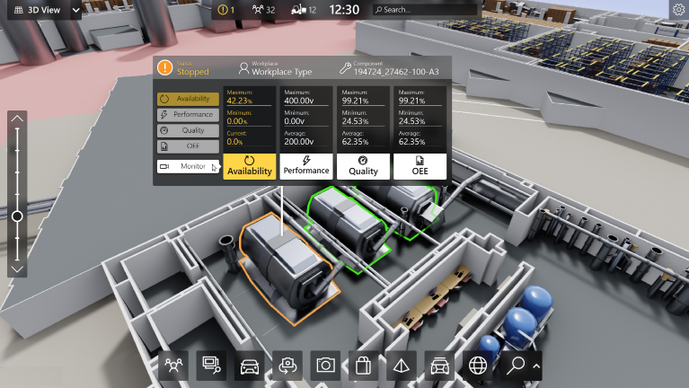

1. 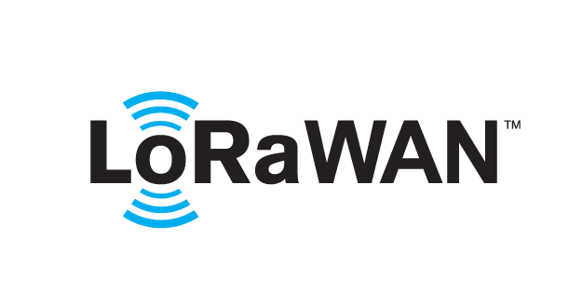 based Solution

UCT is one of the early adopters of LoRAWAN teschnology and providing solution in Agritech, Smart cities, Industrial Monitoring, Smart Street Light, Smart Water/ Gas/ Electricity metering solutions etc.

1. Predictive Maintenance

UCT is providing Industrial Machine health monitoring and Predictive maintenance solution leveraging Embedded system, Industrial IoT and Machine Learning Technologies by finding Remaining useful life time of various Machines used in production process.



## About upskill Campus (USC)

upskill Campus along with The IoT Academy and in association with Uniconverge technologies has facilitated the smooth execution of the complete internship process.

USC is a career development platform that delivers **personalized executive coaching** in a more affordable, scalable and measurable way.





Seeing need of upskilling in self paced manner along-with additional support services e.g. Internship, projects, interaction with Industry experts, Career growth Services

<https://www.upskillcampus.com/>

upSkill Campus aiming to upskill 1 million learners in next 5 year

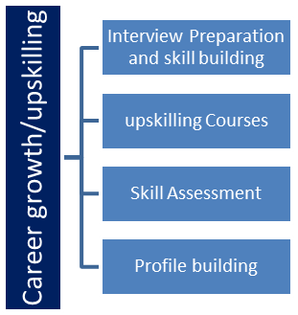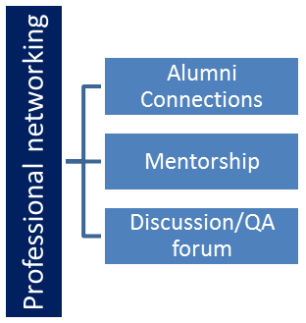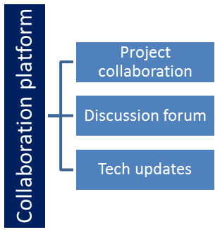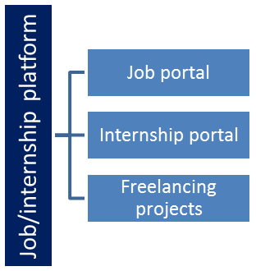



## The IoT Academy

The IoT academy is EdTech Division of UCT that is running long executive certification programs in collaboration with EICT Academy, IITK, IITR and IITG in multiple domains.

## Objectives of this Internship program

The objective for this internship program was to

 ☛ get practical experience of working in the industry.

 ☛ to solve real world problems.

 ☛ to have improved job prospects.

 ☛ to have Improved understanding of our field and its applications.

 ☛ to have Personal growth like better communication and problem solving.



## Reference

[1] https://www.geeksforgeeks.org/gui-to-generate-and-store-passwords-in-sqlite-using-python/

[2] http://www.codewithhaarry.com – for file Handling concept

[3] <https://www.w3schools.com/python/python_arrays.asp>

## Glossary

|  |  |
| --- | --- |
| Terms | Acronym |
| Global Variables | Global variables are variables that belongs to the global scope |
| Random Number | How to create a random number |
| Built-In Data Types | Python has a set of built-in data types |
| Int | The integer number type |
| Float | The floating number type |

# 

# 3 Problem Statement

Are you tired of constantly forgetting your passwords and struggling to keep track of them? Well, look no further! The Password Manager project using Python is here to save the day. This project is designed to help you store your passwords securely and generate new ones when needed. The project uses random and string library to create an easy-to-use graphical interface for the user to interact with. With this application, you can save your passwords locally in a text file, ensuring that they are always accessible when you need them.

The Password Manager In Python project is a command-based application that allows users to securely store, generate, and manage all their passwords. Although it is a simple project, it is user-friendly and can be customized to meet your specific needs. The system requires Python to be installed on your PC to run. You can run the project by either typing "main.py" in the command prompt or double-clicking on the "main.py" file. The project is free to download for educational purposes, and assistance is available if you need help customizing the system.

In today's digital age, security and privacy are of utmost importance. A password manager can help you achieve both by storing all your passwords securely so that you don't have to worry about remembering them. This allows you to use unique, complex passwords for each of your accounts, making it much harder for hackers to gain access. With the Password Manager project using Python, you can rest assured that your passwords are safe and secure.



# Existing and Proposed solution

In conclusion, the Password Manager project using Python is an excellent tool for anyone who struggles with remembering their passwords. It is easy to use and customizable, making it perfect for both personal and professional use. With this application, you can store your passwords securely and generate new ones when needed, ensuring that your accounts are always protected. So why wait? Use the Password Manager project using Python today and take control of your passwords!

## Code submission - https://github.com/Bibha01/Python-Project/blob/main/main.py

## Report submission (Github link) : first make placeholder, copy the link.



# Proposed Design/ Model

A password manager is a python program which allows users to securely store, generate, and manage all their passwords.

This application will generate a password based on the desired length given as input by the user. It will also save the password along with user Name to a database.

In this project I have used random, string functions along with file handling concept.

* The first main menu will be provided about what do you want to do

1. Create password

2. Want your stored password

* If user choose 1. To create password the user will specify the length of the password they want to generate.
* The program will generate a random string of the specified length using the random function.
* The user will provide their Name, which will be saved in the password.txt file along with their password so, that user can retrieve it later also.



# Performance Test

In today's world, where cyber-attacks are becoming increasingly common, cybersecurity has become more important than ever. One of the best ways to protect yourself online is by using a password manager. Password managers not only store your passwords securely but also generate strong passwords for you to use.

In conclusion, building a password manager project using Python is incredibly helpful in the industry. With the increasing need for cybersecurity, it is essential to protect your online accounts by using strong passwords and a password manager. Python makes it easier to create secure applications and automate the login process, saving you time and effort. By utilizing Python's features, you can develop a password manager that meets your needs and helps secure your online presence.



## Test Plan/ Test Cases

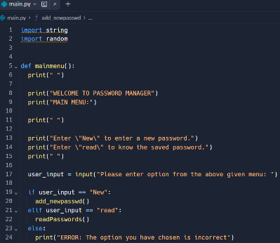

Main menu function which will guid you

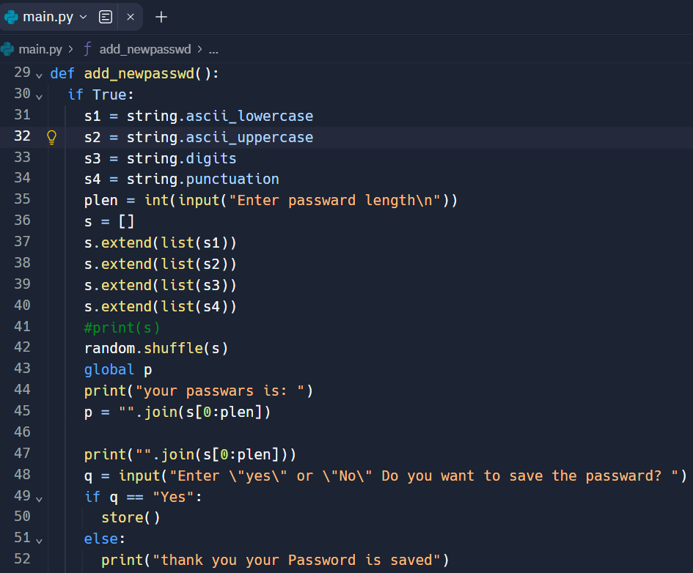

Function to Generate New password

Function to Read saved password



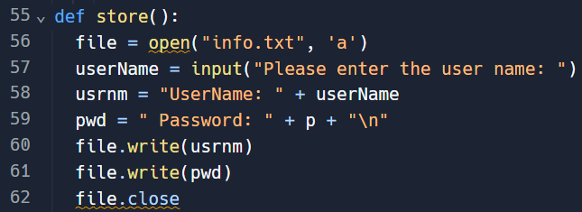

Function to store written Password

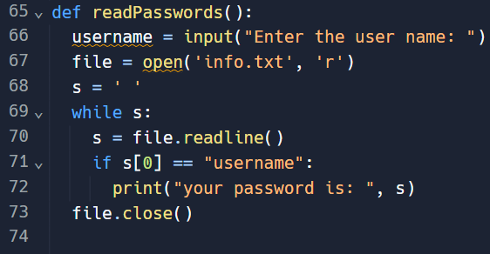

Function to read stored password

**Result**

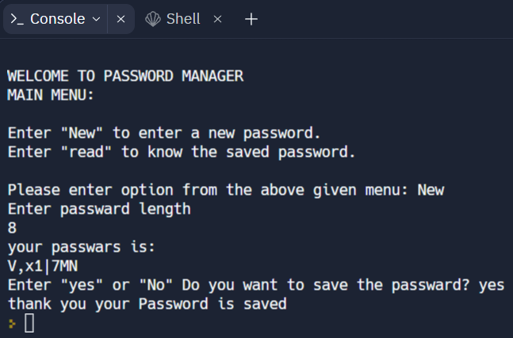



# My learnings

My overall learning experience of learning python from upskill was great. I have learned about it’s basic concept including data type, if else conditions, loops concept, functions and its popular libraries.

Rather than concept I have learnt that Python is a powerful programming language that has gained widespread popularity due to its simplicity and versatility. The benefits of using Python are many, as it can be used for a wide variety of tasks, from building web applications to data analysis. Python has a simple and intuitive syntax that makes it easy to learn and use, making it a great choice for beginners and experienced programmers alike. The concept of Python is to provide a language that is easy to use and read, while still being powerful and flexible enough to handle complex tasks. Overall, Python is an excellent choice for anyone looking to develop efficient and effective software solutions.



# Future work scope

We can add an automatically filling password program to it in the future.